For the presentation:
You will prepare a sample of an unknown acid to titrate using a known concentration of base. You will set-up a burette filled with a known concentration of base and use proper titration techniques to reach an end-point to the titration. You will then calculate the concentration of the unknown acid on your own.
For Part I:
- Create a PowerPoint presentation (4-6 slides) that covers the lab scenario above.
- Include your thoughts on why understanding acid/base titration is important to your future career, and how you will use this concept as you complete your degree.
- Your presentation must consist of more than merely a series of bullet points to earn full credit.
- Use the Notes section for each slide to fully explain your answers.

Dear Students,
Your lab assignment presentation involves putting together a presentation to show other students on how to perform titration. In other words, your presentation can be used to show other students (next term) how they can perform a titration by following your instructions and calculations.

To do this presentation, we are giving you the type of acid, acetic acid, the type of base, NaOH to be used, and you will use phenolphthalein as the indicator. You will use the data given to you to be used as an example of how to solve the mathematical calculations. At the end of your presentation, you will show the unknown concentration of the acetic acid (Molarity) and will also show the % mass/ vol of the Vinegar solution.

Part 1
- Purpose of a titration, what is titration and why do we perform a titration?
- Instrumentation- what are the instruments, glassware used when performing a titration.
- Chemicals and Procedures. What chemicals are needed? List and explain the procedures for this experiment.
- Observations and expectations- List the observations and write your expectations. This might include color change and when the equivalence point (endpoint) might be reached.

Part 2
- Calculations and Results. Show all your calculations and write your results, the Molarity of the acetic and the % of the acetic acid.
- You will use the following for titration calculations:
Concentration of NaOH is 0.1054 M and acetic acid used is 5.00 mL
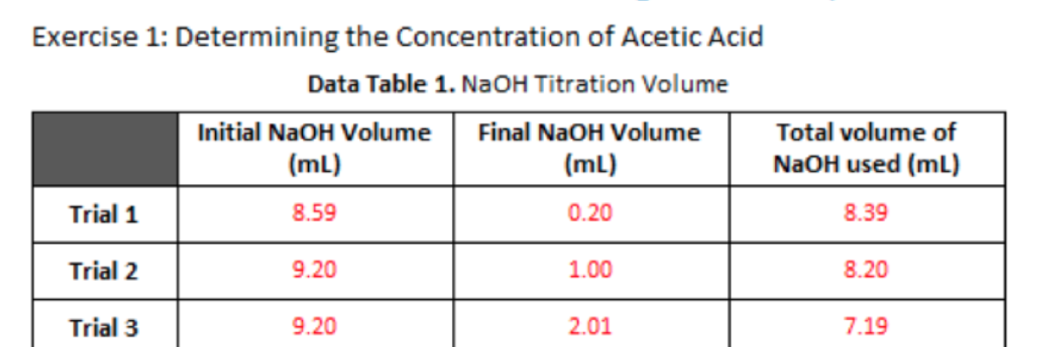

Be sure to show and explain the calculations and to use the numbers sent to you and export as a PDF before uploading.
Also, anywhere that it says 'acetic acid' insert HCl or hydrochloric acid (they calculate the same!)

Be sure to use the AVERAGE of the NaOH volumes
A mass percent calculation
Assume your density is 1.00 g/mL too

This assignment should be in current APA Style with both a title slide and a reference list that includes all the sources used. At least two scholarly sources should be used (your textbook can be one of the sources).

